Hearts and Hands Across the Sea  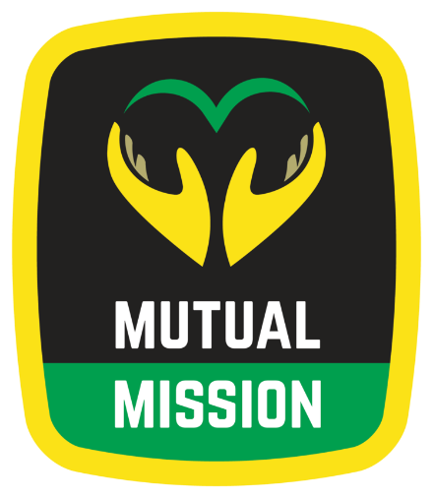  St. Augustine Mutual Mission  Jamaican Ecumenical Mutual Mission |  | For over 40 years we have provided medical and dental services, housing construction and repair, education, counseling (anti-bullying and youth violence prevention), youth and adult exchanges, worship, prayer and spiritual growth through our shared experiences.  For more information, please visit the  Mutual Mission page on the presbytery website:  https://www.staugpres.org/committees-ministries/mutual-mission/
For over 40 years we have provided medical and dental services, housing construction and repair, education, counseling (anti-bullying and youth violence prevention), youth and adult exchanges, worship, prayer and spiritual growth through our shared experiences.  For more information, please visit the  Mutual Mission page on the presbytery website:  https://www.staugpres.org/committees-ministries/mutual-mission/ |  | Hearts and Hands Across the Sea  St. Augustine Mutual Mission  Jamaican Ecumenical Mutual Mission
Hearts and Hands Across the Sea  St. Augustine Mutual Mission  Jamaican Ecumenical Mutual Mission |  | For over 40 years we have provided medical and dental services, housing construction and repair, education, counseling (anti-bullying and youth violence prevention), youth and adult exchanges, worship, prayer and spiritual growth through our shared experiences.  For more information, please visit the  Mutual Mission page on the presbytery website:  https://www.staugpres.org/committees-ministries/mutual-mission/

