Hearts and Hands Across the Sea  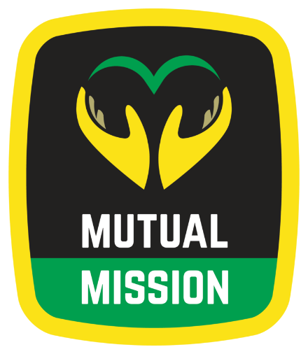  St. Augustine Mutual Mission  Jamaican Ecumenical Mutual Mission |  | For over 35 years we have provided Medical and Dental services, Housing construction and repair, Education, Counseling (anti-bullying and youth violence prevention), Youth and Adult Exchanges, Worship, Prayer and Spiritual Growth through our shared experiences.  For more information, please visit our web site:  www.MutualMission.org
For over 35 years we have provided Medical and Dental services, Housing construction and repair, Education, Counseling (anti-bullying and youth violence prevention), Youth and Adult Exchanges, Worship, Prayer and Spiritual Growth through our shared experiences.  For more information, please visit our web site:  www.MutualMission.org |  | Hearts and Hands Across the Sea  St. Augustine Mutual Mission  Jamaican Ecumenical Mutual Mission
Hearts and Hands Across the Sea  St. Augustine Mutual Mission  Jamaican Ecumenical Mutual Mission |  | For over 35 years we have provided Medical and Dental services, Housing construction and repair, Education, Counseling (anti-bullying and youth violence prevention), Youth and Adult Exchanges, Worship, Prayer and Spiritual Growth through our shared experiences.  For more information, please visit our web site:  www.MutualMission.org

