
August 29, 2026 at Montgomery Conference Center in Starke
88 SE 75th Street
Starke, FL 32091

Join Presbyterian Women of St Augustine Presbytery

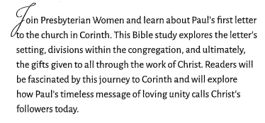

PW Fall Bible Study Kick-off
Daily Agenda
8:30-Registration-continental breakfast
9:30-Welcome, Lighting of Christ Candle, morning devotion
10:00-Opening remarks and Bible Study review/table talk/exercises
11:00-Break
11:20-Continue with Bible Study review/table talk/exercises
12:00 Lunch
1:00 Service Project per table Build a Kit (First Aid and Art)
1:30-50/50 drawing
1:40-Worship with communion
2:15 Departure
Registration: $30.00 before 8/8/2026, late fee will $5 more after that date
Please make checks out to Presbyterian Women
Mail Registration with Checks: Treasurer Sharyn Kraemer 726 Winfred Dr N Orange Park, FL 32073
Name____________________________________________
Church___________________________________________
Email: ____________________________________________
Dietary Restrictions: _________________________________
PW Moderator email: ________________________________
PW Treasurer email: _________________________________
Service Project:
Let’s help Camp Montgomery refill supplies from Summer Camp
Build a first aid kit: Counselor size: we have the pouches we just need to fill them: travel size repellant wipes or small spray, ace bandages, alcohol wipes, sunscreen wipes and band-aids all sizes
Build an Art Kit: Tie Dye-kits-these do not go bad, rubber bands for tie-dye, stickers of all kinds, children’s scissors, colored printer paper, colored pencils, puzzles 500 pieces or bigger (great for rain days at camp).
Shop back to school sales!

